Upper Miramichi Elementary School

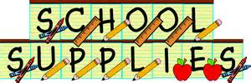

Grade 4 2023/24

- $50 student fee
- Reusable water bottle
- 2 boxes of Kleenex
- 1 boxes of large Ziploc bags
- 1 box of small Ziploc bags
- 1 package of white board markers
- Backpack
- Lunchbox
- Indoor shoes

NOTE:

- If possible, it is a good idea to have supplies at home such as pencils, erasers, notebook, and crayons.

- First day of school- Tuesday, September 5, 2023.

